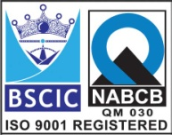****

**“EASCO” PTFE Lined “Y” Type Strainer**

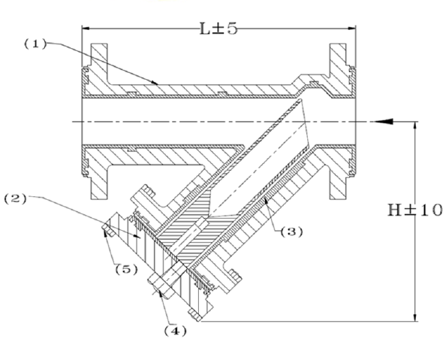

**Features: -**

* Temp: Up to 200 C (PFA Lining)
* Temp: Up to 160 C (FEP Lining)
* Lining Thickness : Minimum 3mm all Parts
* Long Life

**Testing Standard:**

|  |  |
| --- | --- |
| Test Pressure in PSIG | |
| Test | Hydrostatic  ASA150# |
| Pr. Rating |
| Body | 10 |
| Seat | 9.8 |

**Part List: - Standard Dimension (150#): -**

|  |  |  |  |  |  |  |  |  |  |  |  |
| --- | --- | --- | --- | --- | --- | --- | --- | --- | --- | --- | --- |
| **No.** | **Part Name** | **Materials** |  | **Size** | **25** | **40** | **50** | **65** | **80** | **100** | **150** |
| **01** | Body | DI / WCB-CS / (CF8)SS304 / (CF8M)SS316  With PFA or FEP Lining |  | **L** | 190 | 260 | 284 | 318 | 348 | 415 | 508 |
| **02** | Cover |  | **OD** | 108 | 127 | 152 | 178 | 191 | 229 | 279 |
| **03** | Mesh | SS 304 / 316 |  | **PCD** | 79 | 98 | 121 | 140 | 152 | 190 | 241 |
|  | **RF Dia** | 51 | 73 | 92 | 105 | 127 | 157 | 216 |
| **04** | Drain Plug | CS / SS 304/ 316 With PTFE Lined |  | **No. of Hole** | 4 | 4 | 4 | 4 | 4 | 8 | 8 |
| **05** | Cover Bolt & Nut | CS / B7 / 2H / SS 304 / 316 |  | **Hole Dia** | 16 | 16 | 19 | 19 | 19 | 19 | 22 |
| **06** | Gasket | PTFE |  | **H** | 130 | 190 | 205 | 204 | 260 | 310 | 370 |
|  |  |  |  |  |  |  |  |  |  |  |  |
|  |  |  |  |  |  |  |  |  |  |  |  |
|  |  |  |  |  |  |  |  |  |  |  |  |

**Due to continuous development Program, the design & data given in this leaflet are subject to change without prior notice.**

**ANITA ENGINEERING WORKS**



58-59, Narayan Estate, Opp. Shree Ram Estate, Nr. CMC Ltd. Odhav, Ahmedabad-382415, Gujarat, India

Phone: +91 79 22974101, Fax: +91 79 22875014

Email: eascovalves@gmail.com, eascovalves@yahoo.com, Web: [www.eascovalve.com](http://www.eascovalve.com)